User management
In this section, we will cover how to manage multiple users. With user management, we can provide access to Jenkins for multiple users and provide them role-based or project-based access when it is required.
- Go to Manage Jenkins and click on Manage Users:
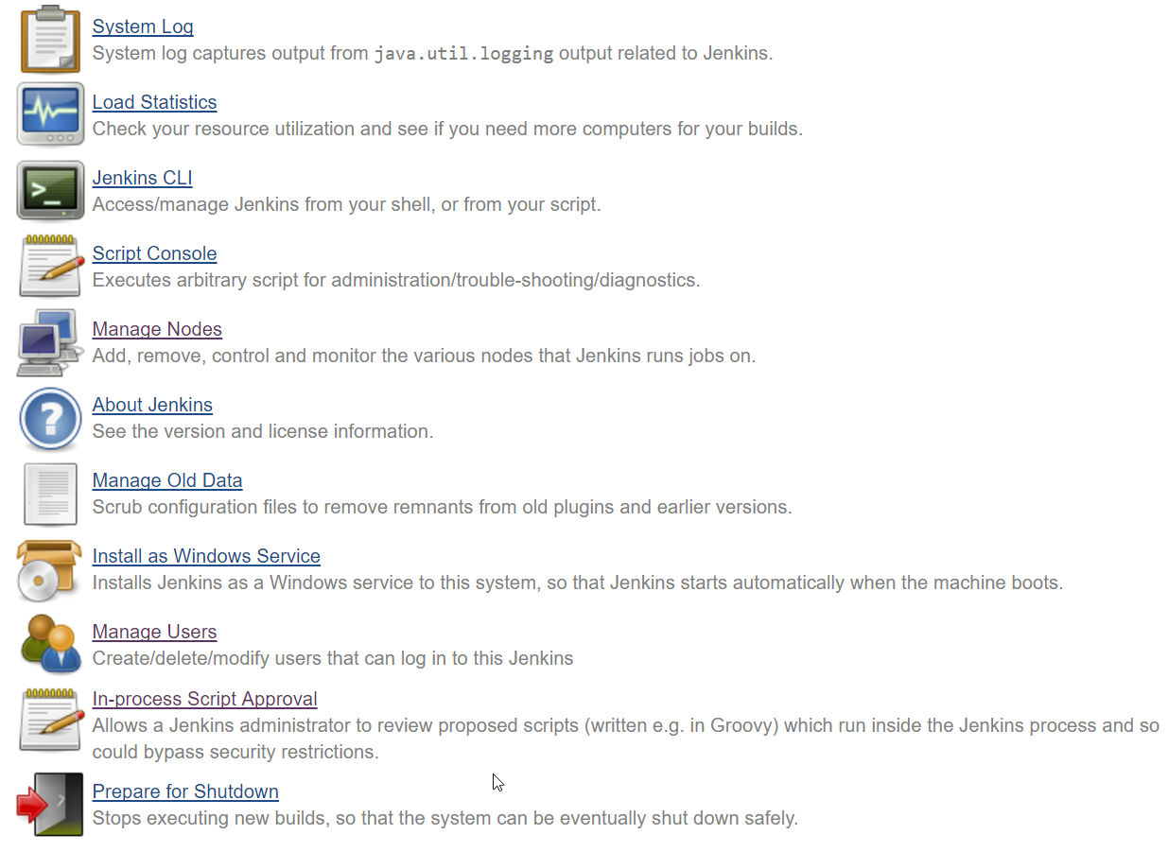
- Check the existing admin user available in Jenkins:
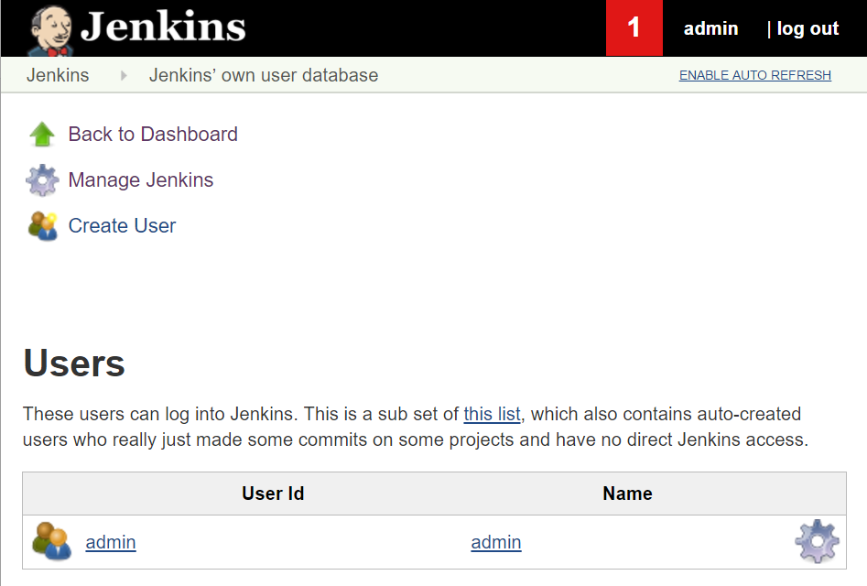
- Click on the Create User link and provide details:
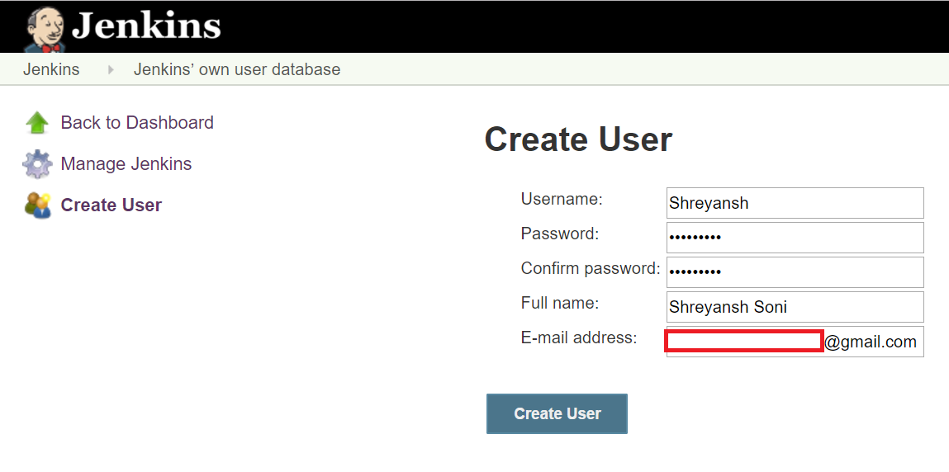
- Check the list of users in Manage Jenkins| Manage Users:
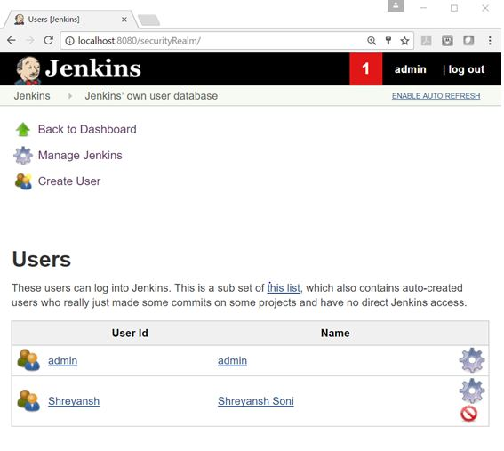
- To allow sign up and access to only logged in users, go to Manage JenkinsÂ |Â Configure Global Security.
- In the Access Control section, click on Jenkins' own user database and select Allow users to sign up:
